Ultrasound Nerve Segmentation

Kaggle Competition Link: https://www.kaggle.com/c/ultrasound-nerve-segmentation#description

Objective:
Segmenting the Brachial Plexus with Deep Learning.
Predict which pixels of an ultrasound image contain the brachial plexus

Data:
5635 Training Images , Size: 420 x 580
Respective Training Masks annotated by humans for each of the training images , 420 x 580
5,508 testing images

What to do?
Pixels in each image belonged to one of two possible classes – Nerve, Not-Nerve
So, of the 243,500 pixels in every image of the testing data, the result set must consist of all the pixels that belong to be a part of the Brachial Plexus nerve.

Train Image ================= Mask Image
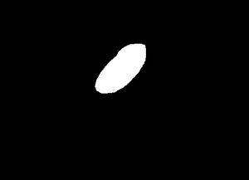
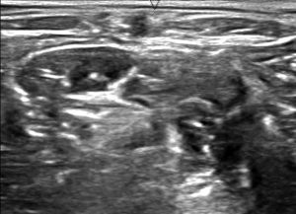

Evaluation:
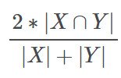
“This competition is evaluated on the mean Dice coefficient. The Dice coefficient can be used to compare the pixel-wise agreement between a predicted segmentation and its corresponding ground truth. The formula is given by:”

Where X is the predicted set of pixels and Y is the ground truth. The Dice coefficient is defined to be 1 when both X and Y are empty. The leaderboard score is the mean of the Dice coefficients for each image in the test set.
(https://www.kaggle.com/c/ultrasound-nerve-segmentation)
Understanding Dice coefficient:
For every image i,
If yi=<yi1, yi2, yi3 . . . . . . . ,yin> is the binary vector identifying the mask for the image i
And ŷ = <ŷi2, ŷi2, ŷi3,. . ,ŷin> be the binary vector predicted
n=420×580=243,600n=420×580=243,600 pixels
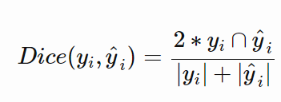

total number of positive pixels in each vector
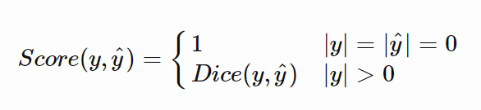

Model
Step 1:
The basic model, was a direct implementation of U-NET as in this paper: https://arxiv.org/pdf/1505.04597.pdf
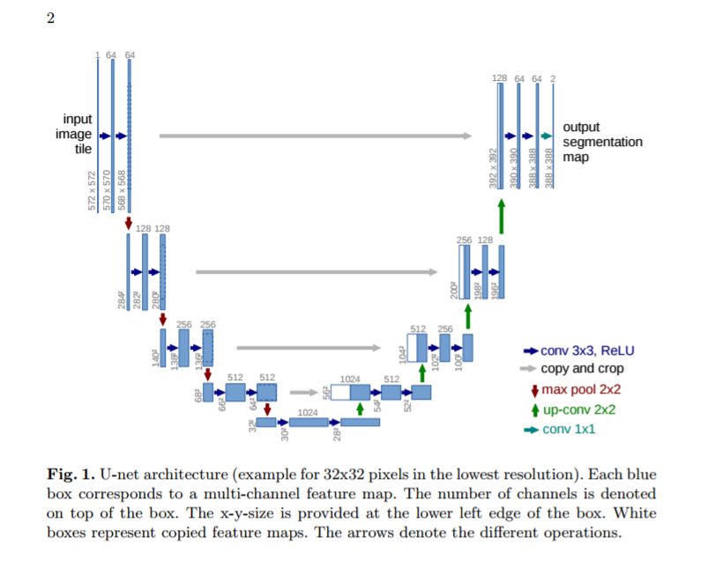

The network was built in Keras using Marko Jocic’s.
Initial model was something like this:
Code Snippet:

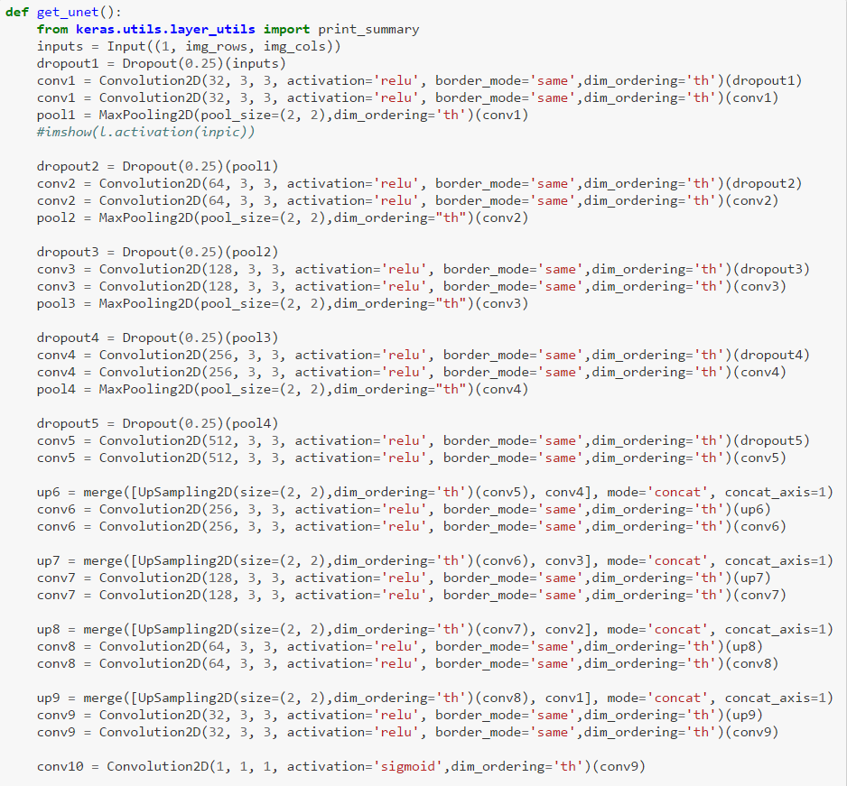

Model Structure – Layers involved and Output of each layer is as follows:

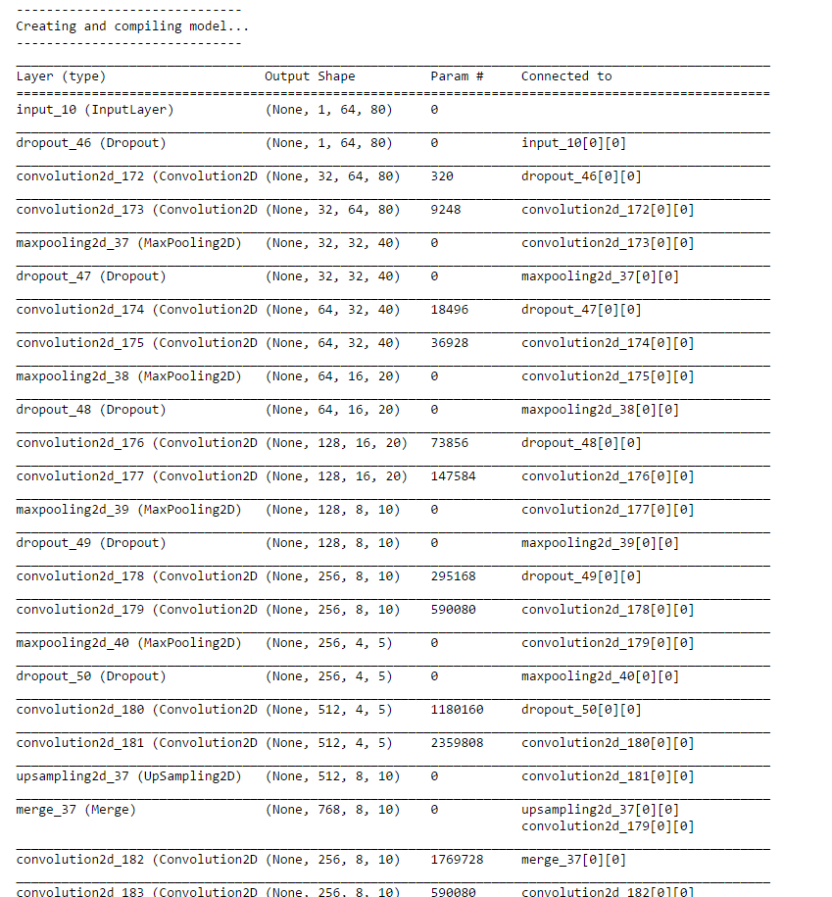

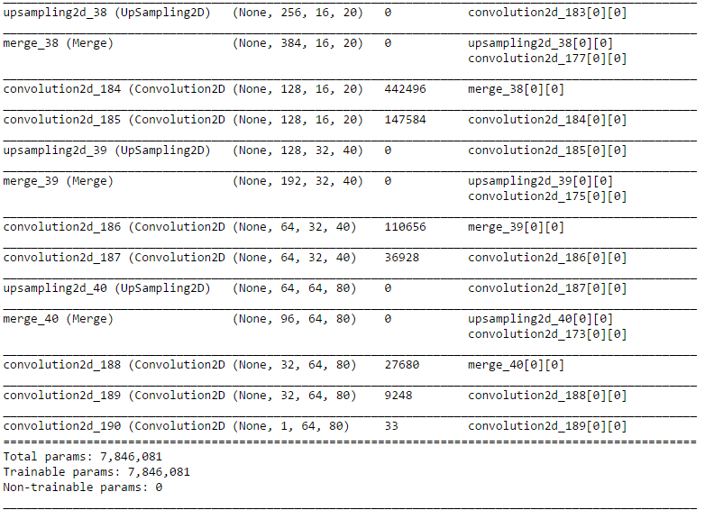

This was then modified to have the following changes:
- Two levels deeper with 1024 and 2048 channels
- Dropout channels – Tried both 0.25, 0.5
When the extra depth was added, the training time increased.
Dice coefficient and loss didn’t seem to have any significant changes due to this.
Hence, retained the model upto 512 channels
Retained Droput of 0.25.

Input to the model: Converting images to Numpy Array
The images, when read are converted in Numpy ndArray and stored in .npy files.
These files are loaded when required.
Loading the images, convert them into numpy arrays
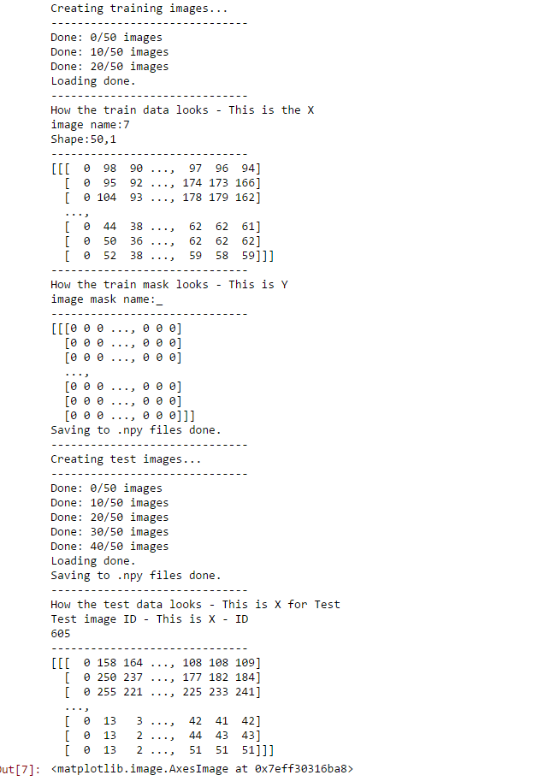

Data Preprocessing:
The images were of high resolution and took time to process.
Hence, were resized. Two of these sizes were tested:
64x96 and 64x80
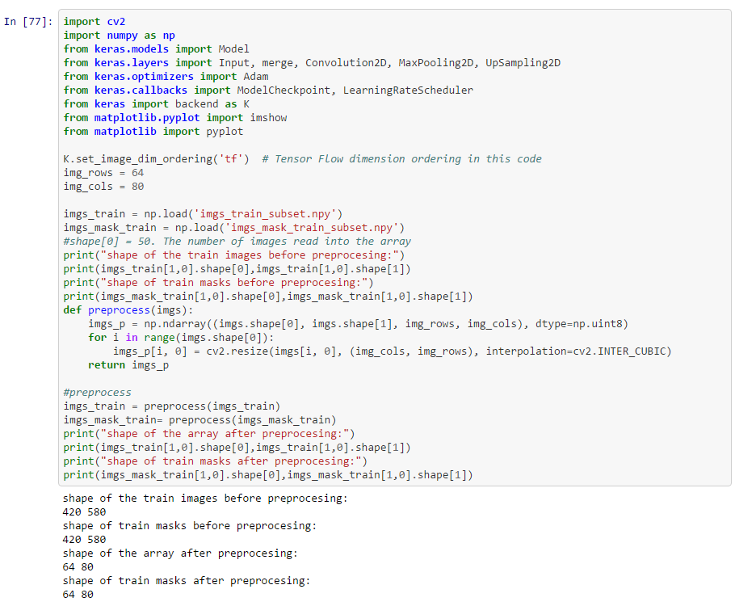

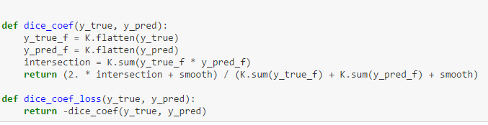
The Dice coefficient & loss metrics were defined for the model as below:

Compiling the model:
The first compilation was evaluating loss as Dice Coeff. Used the Adam optimizer with regularization of 1e-5 as below.

One epoch running on 50 training images gave a dice coeff of 0.2848 as below.
Printing the masks array that was predicted is as below:
This was a test run, with absolutely no data augmentation while model fitting.
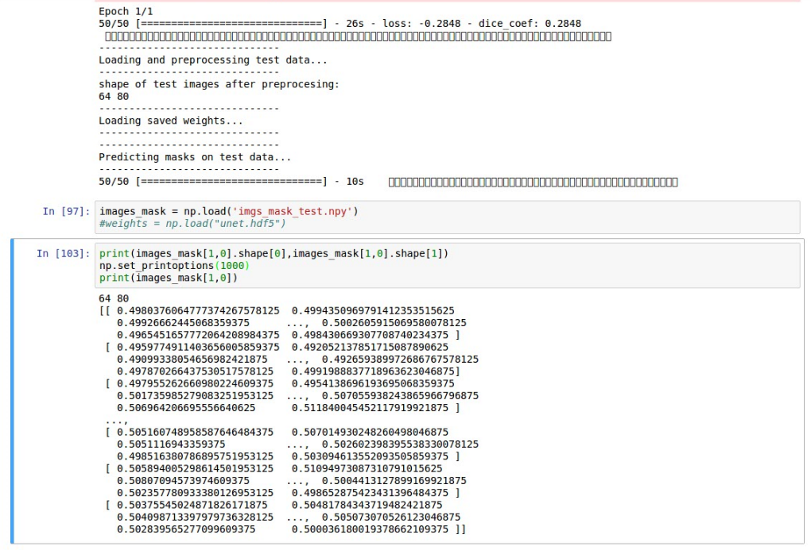

experimenting compilation
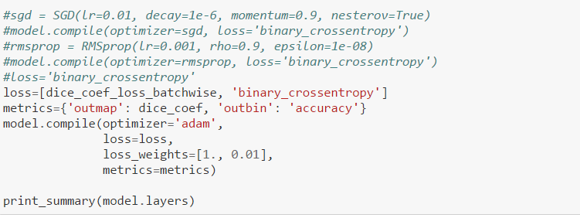

Fitting Test Data:
Before using the compiled model to predict for data, some basic data processing is done to make sure we get accurate results

Zero-centering and Standardizing:
The first and simple pre-processing approach is zero-center the data, and then normalize them, which is presented as two lines codes as follows:
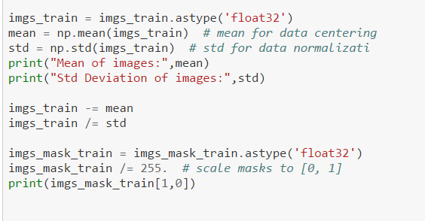

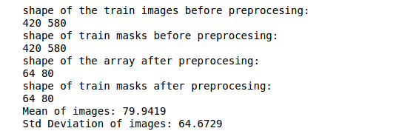

DATA AUGMENTATION
In order to make the most of the few training examples, "augmenting" them via a number of random transformations, so that our model would never see twice the exact same picture
This helps prevent overfitting and helps the model generalize better.
In Keras this can be done via the keras.preprocessing.image.ImageDataGenerator class. This class allows you to:
- Configure random transformations and normalization operations to be done on your image data during training
instantiate generators of augmented image batches (and their labels) via .flow(data, labels) or .flow_from_directory(directory)
- These generators can then be used with the Keras model methods that accept data generators as inputs, fit_generator, evaluate_generator and predict_generator.

For 50 subset images, a basic DataGenerator was built with Horizontal and Vertical Flip augmentations.
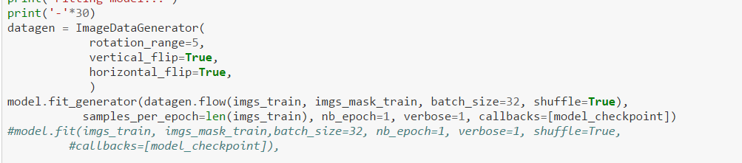
Then, the pre-processed Train and Test data are loaded and U-net weights were calculated.
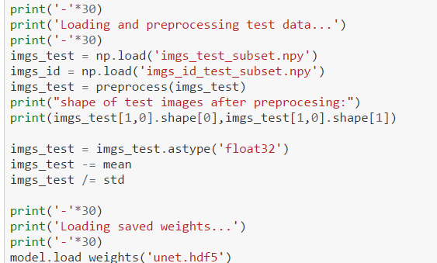

Masks are then predicted
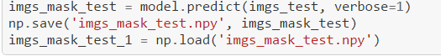

INPUT for training
Loading and Printing pre-processed Training Images and Training Mask Images (Random 3 images from the array)
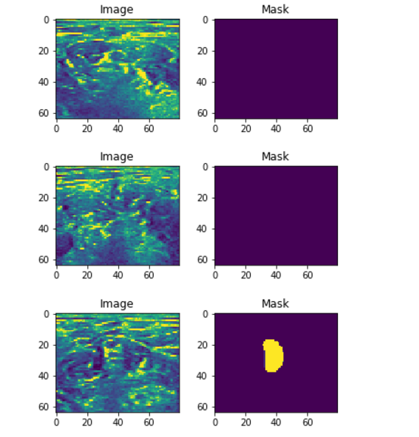

Output after ONE Epoch on 50 Training images
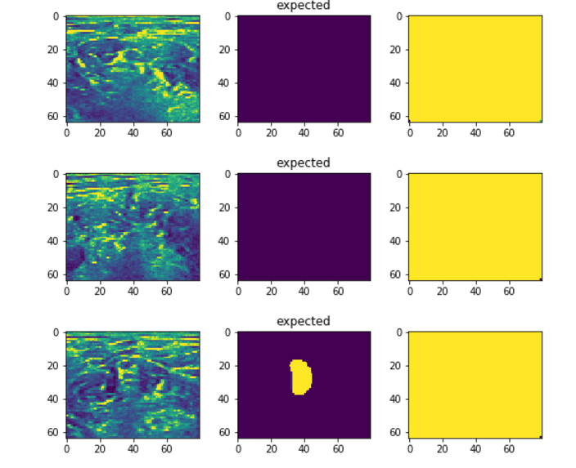

To see how the model converges, 50 epochs on the local machine
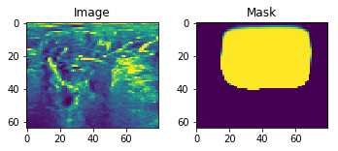

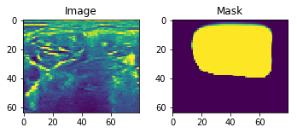

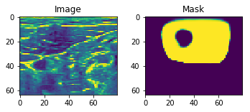

Output & Submission - Run-length encoding on the pixel values
Kaggle submissions required a csv file consisting of pairs of values that contain a start position and a run length.
E.g. '1 3' implies starting at pixel 1 and running a total of 3 pixels (1,2,3).
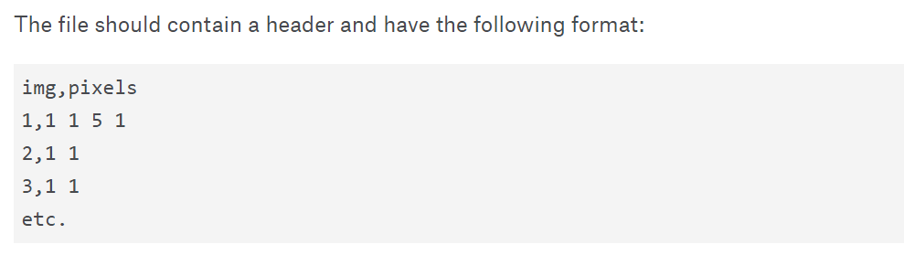

Once the masks are saved in a .npy file, it is used to create the submission CSV. There exists a kernel that does this for the masks obtained.
https://www.kaggle.com/alexlzzz/ultrasound-nerve-segmentation/rl-encoding

